**FROG DISSECTION PRE-LAB**

1. Which body system protects our organs, gives the body structure, and allows us to move?

___________________________________

1. Which body systems delivers blood all over our body? ___________________________
2. Arteries are blood vessels that carry blood ______________________ the heart.
3. Which body systems breaks down food into nutrients? _________________________________
4. Which body system tells the skeletal system to move? __________________________________
5. Which body system brings air into the lungs?__________________________________________
6. You go out for a jog in the spring to shed some winter pounds. Which body systems are working? Explain how.

________________________________________________________________________________________________________________________________________________________________________________________________________________________________________________________________________________________________________________________________________________________________________________________________________________________________________________________________________________________________________________________________________________________________________________________________________________________________________________________________

________________________________________________________________________________

________________________________________________________________________________

**Frog Dissection Pre-Lab**

Directions: Read the following information about dissections and about frogs. Then, answer the pre-lab questions.

**Important Dissection Vocabulary:**

* Dissect: to cut something open and study it carefully
* Anatomy: the study of body structure (the shape of the body and what the body is made of)
* *External* anatomy: the outer structure of an organism (Ex: skin, outer organs, like the ears)
* *Internal* Anatomy: the inner structure of an organism (Ex: inside organs, like the stomach)
* Vertical: going up and down
  + A vertical line looks like this:
* Horizontal: going from side to side
  + A horizontal line looks like this:

**Digestive System Organs**

* Mouth
* Esophagus
* Stomach
* Intestines

bile is a digestive juice that helps break down fats!

* Rectum and anus
* Liver: gets rid of toxins (poisons) in the body, makes bile
* Gallbladder: stores and releases bile
* Kidneys: two bean-shaped organs that filter blood

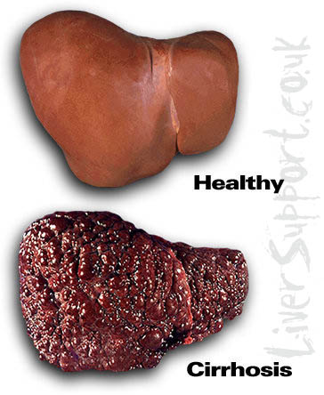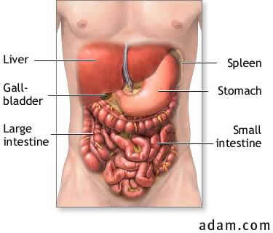

Healthy liver

Unhealthy liver

**Parts of the Circulatory and Respiratory Systems**

* Heart
* Lungs
* Blood
* blood vessels
* Trachea: the windpipe (what you breathe through)
* Glottis: the flap that covers the windpipe when you’re swallowing

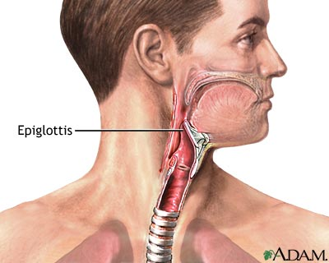

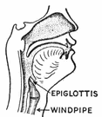

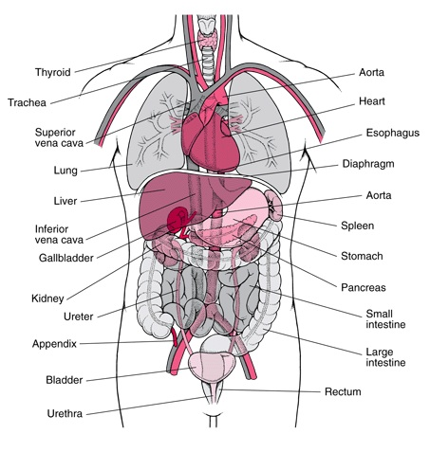

**Ten Things You Need to Know About Frogs**

**1**. Frogs Are Amphibians.

* Amphibians are animals that spend half their life on land and half on water
  + Amphibian means “double life”

**2.** Amphibians are cold-blooded vertebrate animals.

* They are different from reptiles in that they lack scales and generally return to water to breed (reproduce).

**3.** When a frog swallows a meal, his bulgy eyeballs will close and go down into his head! This is because the eyeballs apply pressure and actually push a frog's meal down his throat

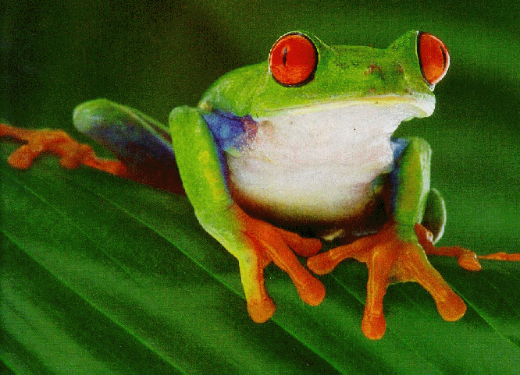

**4.** Frogs have teeth.

* They have two vomerine teeth in the middle of the roof of the mouth
* They have two maxillary teeth at the sides of the mouth

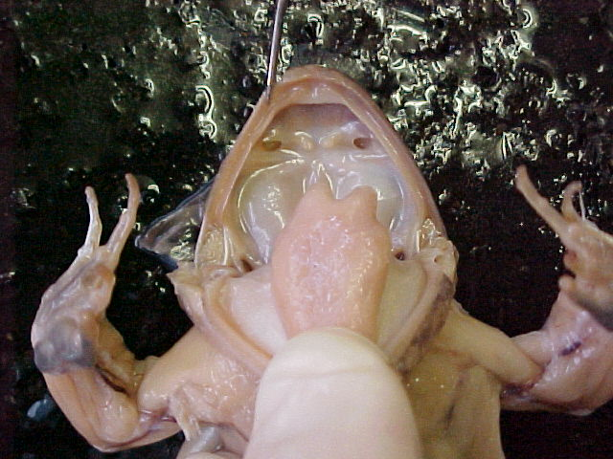

**5.** Frogs’ ears are called tympani, or tympanic membranes.

* These ears pick up vibrations from the water and the air and turn them into sound waves so that the frog can hear.

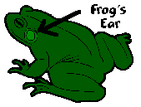

**6.** When they’re underwater, frogs breathe through their skin.

* Frogs usually live near water because they need to keep their skin wet so they can breathe through it!

**7.** When they’re on land, frogs breathe through lungs.

* Air enters through their mouth and external nares (nostrils)

**8.** Frogs usually lay their eggs in water.

* Each female lays hundreds to thousands of eggs at a time, in slimy masses.

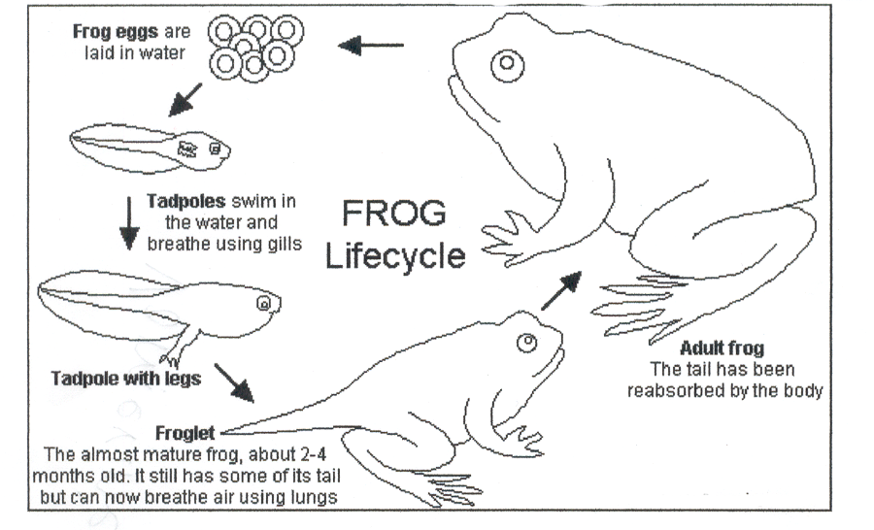

**9.** You can determine the sex of a frog by looking at its thumbs.

* A male frog usually has thick pads on its "thumbs," which is one external difference between the males and females, as shown below.
* Male frogs are also usually smaller than females.



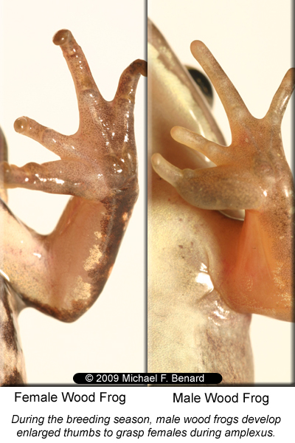

**10.** Frogs have 3 eyelids.

* The nictitating membrane is a third eyelid.
* It is clear and protects the frogs’ eyes when it is underwater.
* It keeps the eyes moist when the frog is on land.
* Frog Eyelid: Nictitating membrane:

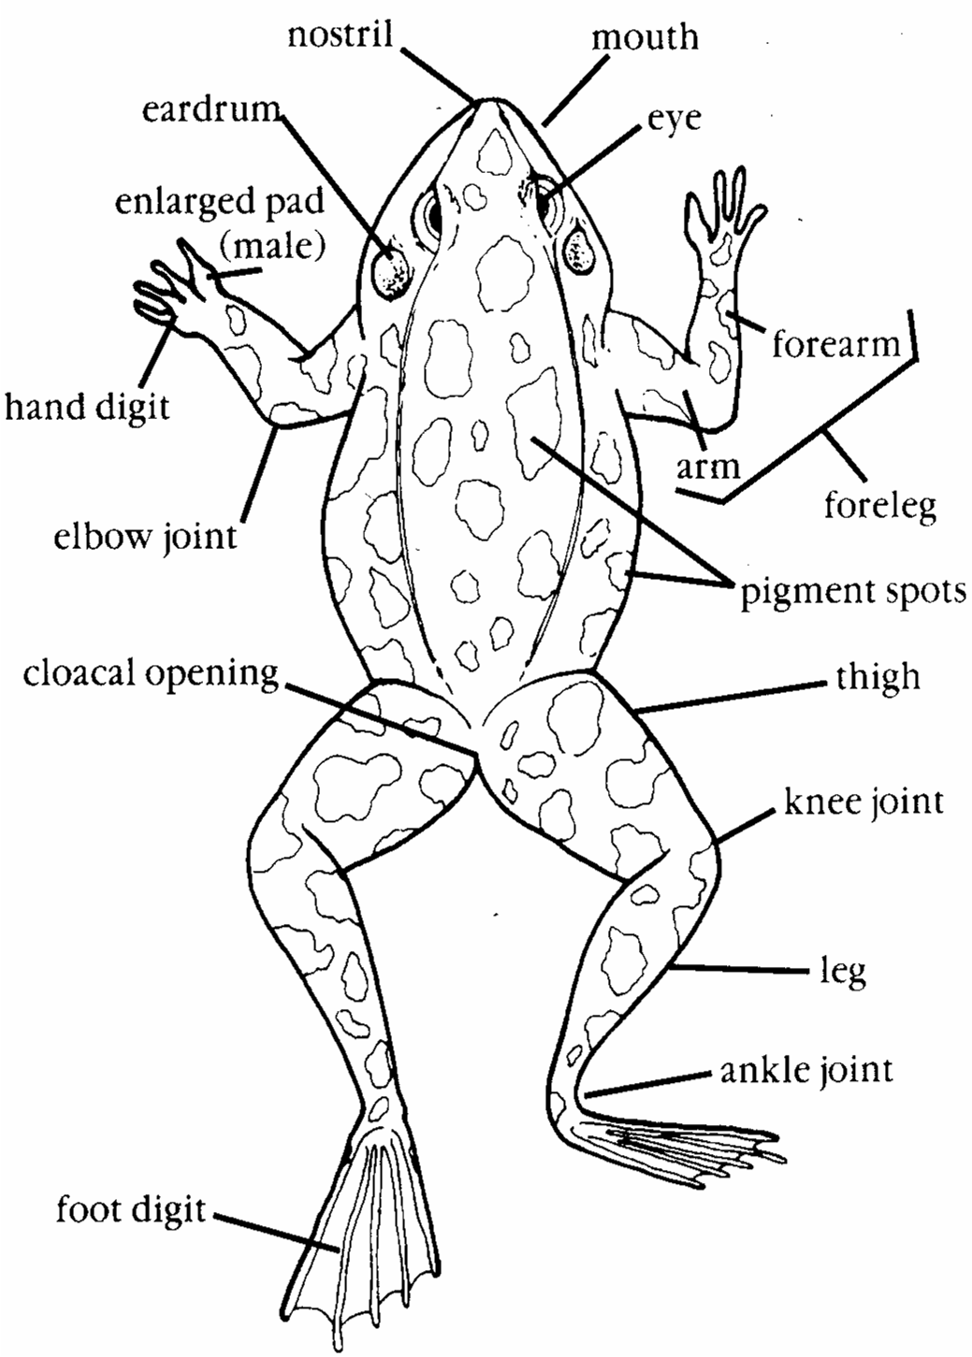

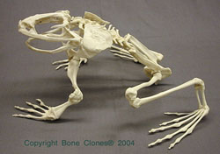

Fun fact: The skeletal shape of the frog has remained almost unchanged over the last 190 million years!

1. Tomorrow, we are going to dissect a frog. In your own words, what does “dissection” mean? ____________________________________________________________________

__________________________________________________________________________

1. We will first be studying the external anatomy of the frog, then the internal anatomy. In your own words, what is the difference between external anatomy and internal anatomy? ____________________________________________________________________________________________________________________________________________________
2. What level of organization is a frog? (cell, tissue, organ, organ system, organism) ______________________
3. What are frog ears called? ___________________________
4. How do frog ears work? ______________________________________________________

__________________________________________________________________________

1. What are frog teeth called? (There are 2 kinds of teeth). ____________________________

__________________________________________________________________________

1. Where in the mouth are these 2 kinds of teeth located? _____________________________

__________________________________________________________________________

1. How do frogs breathe? (There are 2 ways. Explain both). ____________________________

__________________________________________________________________________

1. How can you determine the sex (gender) of your frog, just by looking at its external anatomy? __________________________________________________________________

____________________________________________________________________________________________________________________________________________________

1. What is the nictitating membrane, and why do frogs have them? _____________________

____________________________________________________________________________________________________________________________________________________

1. How do you think the frog’s anatomy will be different from your own anatomy? How do you think it will be similar? Write at least 6 similarities and/or differences below in the Venn Diagram.